**Expert ID/Name: Nstructive**

**Date: 10-Nov-2020**

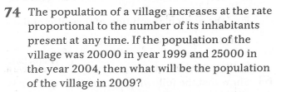

|  |
| --- |
| Answer for Short / Simple / Direct Question |

|  |
| --- |
| **Tips:**  . Convert the given condition into differential equation.  . |

**Answer:**

|  |  |  |  |  |  |  |  |  |  |  |  |  |
| --- | --- | --- | --- | --- | --- | --- | --- | --- | --- | --- | --- | --- |
| Given: The population of a village increase at the rate proportional to number of its inhabitants present at any time.  To find: The population of the village in such that population of village was in the year and in the year.  Explanation: -  Step1:   |  |  | | --- | --- | | Instruction: | Convert the given condition into differential equation. | | Calculation: | Let be the population at the time .  Then |   Step 2:   |  |  | | --- | --- | | Instruction: | Integrate on both sides with respect to. | | Calculation: | In the year ,  From equation (1) , we get |   Step 3:   |  |  | | --- | --- | | Instruction: | For year .  Put the values of and in equation (1)  Use the formula: | | Calculation: | Hence, the Population of village in is | |
| Verified Answer: -Hence verified. |